**STAT 40001/STAT 59800 Statistical Computing Fall 2020**

**Lab-13**

1. The estimation of the average shrinkage percentage of plastic clay should have an error bound of 0.2 with 98% confidence. A pilot sample of 50 gave standard deviation of 1.2. Determine the sample size that should be used.

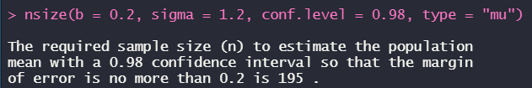

1. A food processing company, considering the marketing of a new product, is interested in the proportion p of consumers that would try the new product. In a pilot sample of 40 randomly chosen consumers, 9 said that they would purchase the new product and give it a try. What sample size is needed for the 90% CI for p to have length 0.1.

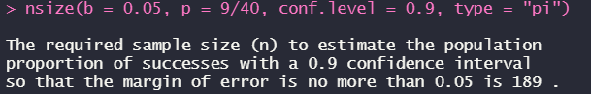

1. Suppose that you are determining the power of the test for a given sample size for a two-sided independent samples t-test with significant level of 0.05 and effect size d=0.7. Generate a table showing the power of the test for following sample size:

n=5,10,15,20,25,30,35,40,45,50,55,60,65,70,75,80,85,90,100

> library(pwr)

> power=cbind(NULL,NULL)

> for(i in seq(5,100,5)){

+ p1=power.t.test(d=0.7,n=i,sig.level=0.05,alt="two.sided",type="two.sample")

+ power=rbind(power,cbind(p1$n,p1$power))}

> power

[,1] [,2]

[1,] 5 0.1631800

[2,] 10 0.3163866

[3,] 15 0.4566869

[4,] 20 0.5782714

[5,] 25 0.6790886

[6,] 30 0.7599031

[7,] 35 0.8229728

[8,] 40 0.8711328

[9,] 45 0.9072448

[10,] 50 0.9339067

[11,] 55 0.9533297

[12,] 60 0.9673141

[13,] 65 0.9772788

[14,] 70 0.9843134

[15,] 75 0.9892382

[16,] 80 0.9926597

[17,] 85 0.9950205

[18,] 90 0.9966389

[19,] 95 0.9977420

[20,] 100 0.9984898

> plot(power,xlab="Sample Size", ylab="Power", main="Sample Size Vs. Power ",type="b",col=2)



1. Suppose that you are determining the required sample size for a two-sided independent samples t-test with 80% power and significant level of 0.05.

Generate a table showing the required sample size for each of the following effect sizes:

d = 0.1, 0.2, 0.3, 0.4, 0.5, 0.6, 0.7, 0.8, 0.9, 1.0, 1.1, 1.2, 1.3, 1.4, 1.5

Create a table showing the effect size versus sample size. Plot the graph for effect size versus sample size.

